College of Arts and Sciences

Offices of the Associate
and Assistant Deans

114 University Hall
230 North Oval Mall
Columbus, OH 43210

614-292-1667 Phone
asc.osu.edu

February 7, 2019

Vice-Provost Randy Smith
Office of Academic Affairs
Ohio State University

Dear Randy,

I am writing to express the College of Arts and Sciences’ strong support for the proposed certificate program in Diversity, Equity, and Inclusion. This is a wide-reaching and important interdisciplinary program that should appeal both to our population of matriculated undergraduate students and also to students who have already earned Bachelor’s degrees returning from the workforce to earn this certificate. This program will make an important contribution toward achieving our university mission of “Education for Citizenship.” Thank you, and the Council on Academic Affairs, for considering this curricular proposal.

Sincerely,
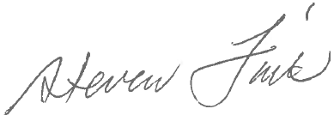
Steve Fink
Associate Executive Dean
College of Arts and Sciences
fink.5@osu.edu

